Digital Signal Processing
Huzaifa Shahbaz
Lab report #13
Introduction to Filters in Digital Signal Processing (DSP): FIR and IIR
TASK#1: An FIR filter is designed by finding the coefficients and filter order that meet certain specifications, which can be in the time-domain (e.g. a matched filter) and/or the frequency domain (most common). Matched filters perform a cross-correlation between the input signal and a known pulse-shape. The FIR convolution is a cross-correlation between the input signal and a time-reversed copy of the impulse-response. Therefore, the matched filter's impulse response is "designed" by sampling the known pulse-shape and using those samples in reverse order as the coefficients of the filter. CODE: import numpy as np
import matplotlib.pylab as plt
from scipy.signal import firwin,freqz
wp=0.375*np.pi
ws=0.5*np.pi
wt=ws-wp
n1=np.ceil(8*np.pi/wt)
N=int(n1+(n1-1)%2)
print('Order of the FIR filter N=',N)
Wc1=wp+wt/2
fs=2*np.pi
Wc=Wc1/(0.5*fs)
print('Cutoff frequency =',Wc)
h=firwin(N,Wc,window='hamming')
print('Impluse Response of FIR filter:')
print(h)
plt.figure(1)
w,H=freqz(h)
plt.stem(w,np.abs(H))
plt.title('Frequency Response')
plt.xlabel("Frequency (radians)")
plt.ylabel('Magnitude')
plt.grid(True)
plt.figure(2)
n=np.arange(N)
plt.stem(n,h)
plt.xlabel('n')
plt.ylabel('h(n)')
plt.title('Impluse Response of Filter')
plt.grid(True)
plt.show() OUTPUT: 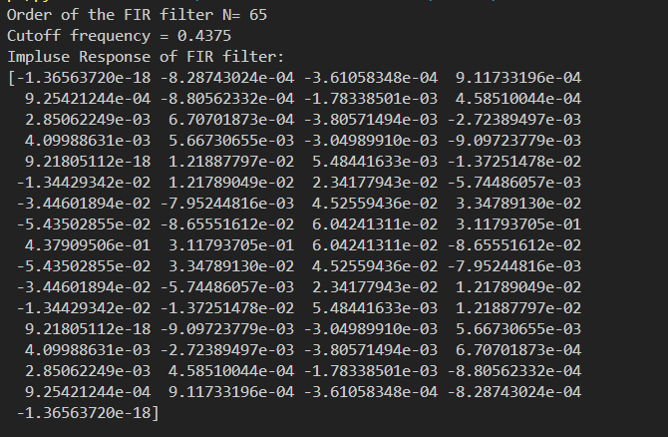 GRAPH: 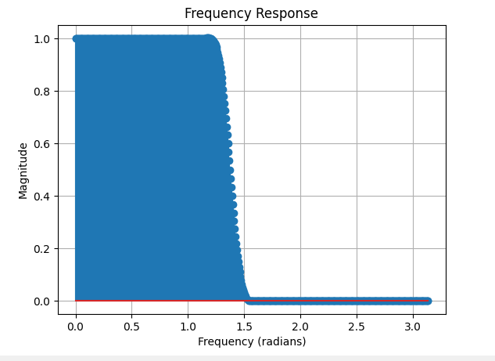 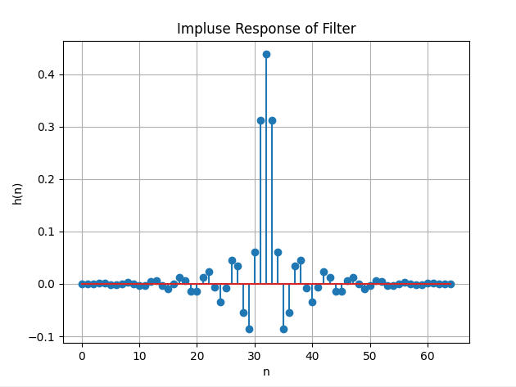 TASK#2: An FIR filter is designed by finding the coefficients and filter order that meet certain specifications, which can be in the time-domain (e.g. a matched filter) and/or the frequency domain (most common). Matched filters perform a cross correlation between the input signal and a known pulse-shape. The FIR convolution is a cross-correlation between the input signal and a time-reversed copy of the impulse-response. Therefore, the matched-filter's impulse response is "designed" by sampling the known pulse-shape and using those samples in reverse order as the coefficients of the filter. CODE:
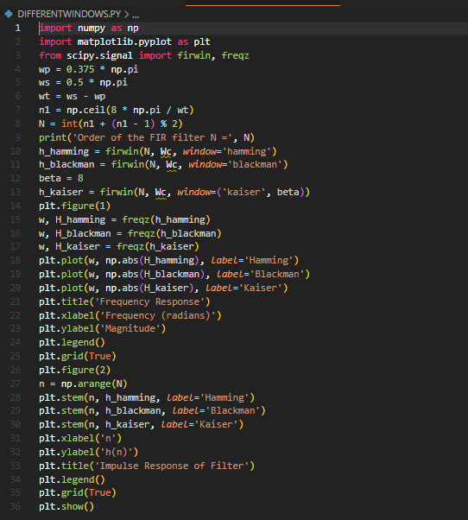 Graph: 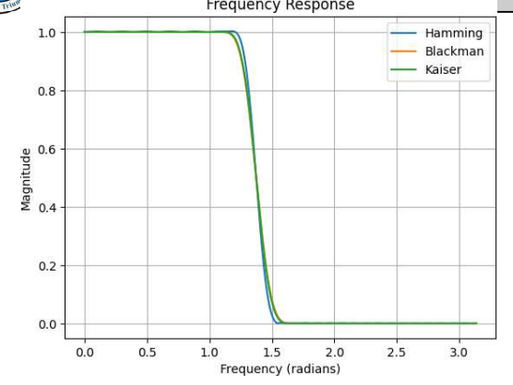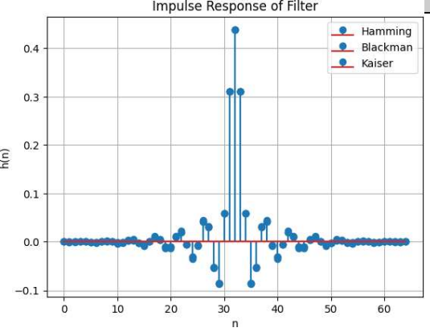 TASK#3: IIR filters are digital filters with infinite impulse response. Unlike FIR filters, they have the feedback (a recursive part of a filter) and are known as recursive digital filters therefore. For this reason IIR filters have much better frequency response than FIR filters of the same order. Unlike FIR filters, their phase characteristic is not linear which can cause a problem to the systems which need phase linearity. For this reason, it is not preferable to use IIR filters in digital signal processing when the phase is of the essence. Otherwise, when the linear phase characteristic is not important, the use of IIR filters is an excellent solution. CODE:
import numpy as np
import matplotlib.pyplot as plt
from scipy.signal import butter, cheby1, freqz
from scipy.constants import pi
# Step I: Enter the pass band ripple (rp) and stop band ripple (rs)
rp = 0.1
rs = 40
# Step II: Enter the pass band frequency (wp) and stop band frequency (ws)
wp = 0.375 * pi
ws = 0.5 * pi
# Step III: Get the sampling frequency (fs)
fs = 2 * pi
# Step IV: Calculate normalized pass band frequency, and normalized stop band frequency w1 and w2 respectively
w1 = 2 * wp / fs
w2 = 2 * ws / fs
# Step V: Calculate the filter order
# Butterworth filter order
# [n, wn] = buttord(w1, w2, rp, rs)
# Chebyshev filter order
# [n, wn] = cheb1ord(w1, w2, rp, rs)
# Example filter order and wn values for demonstration
n = 6
wn = 0.4
# Step VI: Design an nth order digital low pass Butterworth or Chebyshev filter
# Butterworth filter
b, a = butter(n, wn)
# Chebyshev filter
# b, a = cheby1(n, rp, wn)
# Step VII: Find the digital frequency response of the filter
w, H = freqz(b, a)
# Step VIII: Calculate the magnitude of the frequency response in decibels (dB)
mag = 20 * np.log10(abs(H))
# Step IX: Plot the magnitude response [magnitude in dB Vs normalized frequency]
plt.figure(1)
plt.plot(w, mag)
plt.title('Magnitude Response')
plt.xlabel('Normalized Frequency')
plt.ylabel('Magnitude (dB)')
plt.grid(True)
# Step X: Calculate the phase response using angle(H)
phase = np.angle(H)
# Step XI: Plot the phase response [phase in radians Vs normalized frequency (Hz)]
plt.figure(2)
plt.plot(w, phase)
plt.title('Phase Response')
plt.xlabel('Normalized Frequency')
plt.ylabel('Phase (radians)')
plt.grid(True)
plt.show() Graph: 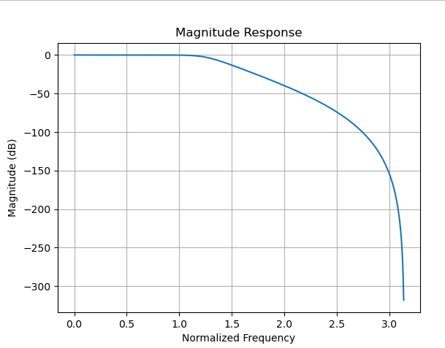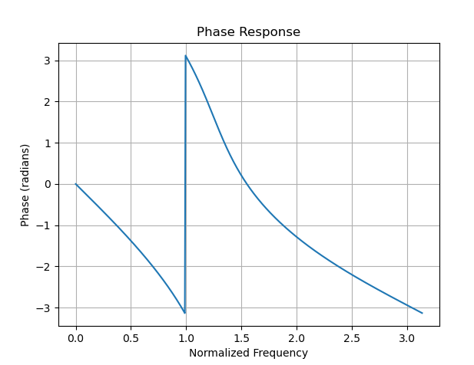
TASK#4: IIR filters are digital filters with infinite impulse response. Unlike FIR filters, they have the feedback (a recursive part of a filter) and are known as recursive digital filters therefore. For this reason IIR filters have much better frequency response than FIR filters of the same order. Unlike FIR filters, their phase characteristic is not linear which can cause a problem to the systems which need phase linearity. For this reason, it is not preferable to use IIR filters in digital signal processing when the phase is of the essence. Otherwise, when the linear phase characteristic is not important, the use of IIR filters is an excellent solution. CODE: import numpy as np
import matplotlib.pyplot as plt
from scipy.signal import butter, cheby1, ellip, freqz
# Filter specifications
order = 4
cutoff_freq = 0.2 # Normalized cutoff frequency
# Design the Butterworth filter
b_butter, a_butter = butter(order, cutoff_freq, btype='low', analog=False, output='ba')
# Design the Chebyshev Type I filter
rp_cheby1 = 1 # Passband ripple in dB
b_cheby1, a_cheby1 = cheby1(order, rp_cheby1, cutoff_freq, btype='low', analog=False, output='ba')
# Design the elliptic filter
rp_ellip = 1 # Passband ripple in dB
rs_ellip = 40 # Stopband attenuation in dB
b_ellip, a_ellip = ellip(order, rp_ellip, rs_ellip, cutoff_freq, btype='low', analog=False, output='ba')
# Compute the frequency response for each filter
w, h_butter = freqz(b_butter, a_butter)
w, h_cheby1 = freqz(b_cheby1, a_cheby1)
w, h_ellip = freqz(b_ellip, a_ellip)
# Plot the magnitude response for each filter
plt.figure()
plt.plot(w, np.abs(h_butter), label='Butterworth')
plt.plot(w, np.abs(h_cheby1), label='Chebyshev Type I')
plt.plot(w, np.abs(h_ellip), label='Elliptic')
plt.title('Magnitude Response')
plt.xlabel('Frequency (radians)')
plt.ylabel('Magnitude')
plt.legend()
plt.grid(True)
# Plot the phase response for each filter
plt.figure()
plt.plot(w, np.angle(h_butter), label='Butterworth')
plt.plot(w, np.angle(h_cheby1), label='Chebyshev Type I')
plt.plot(w, np.angle(h_ellip), label='Elliptic')
plt.title('Phase Response')
plt.xlabel('Frequency (radians)')
plt.ylabel('Phase (radians)')
plt.legend()
plt.grid(True)
plt.show() Graph: 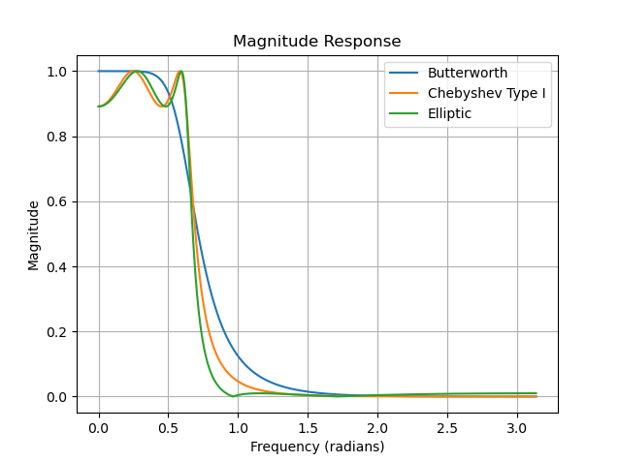 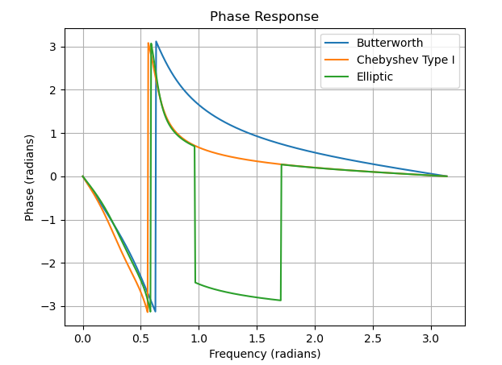
TASK#5: Hamming Window Write a Python program to design an FIR filter using the Hamming window. Perform the following steps: Define the input specifications: wp = 0.375 * np.pi, ws = 0.5 * np.pi. Calculate the order of the filter using the formula N = int(np.ceil(8 * np.pi / (ws - wp)) + 1). Calculate the cutoff frequency: Wc = (wp + (ws - wp) / 2) / (0.5 * np.pi). Calculate the filter coefficients using the Hamming window: h_hamming = firwin(N, Wc,window='hamming'). Plot the frequency response and impulse response for the Hamming window. Display the plots. CODE: 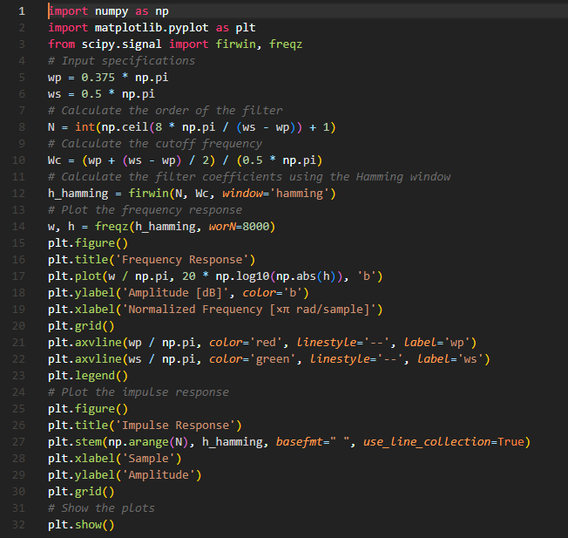 Graph: 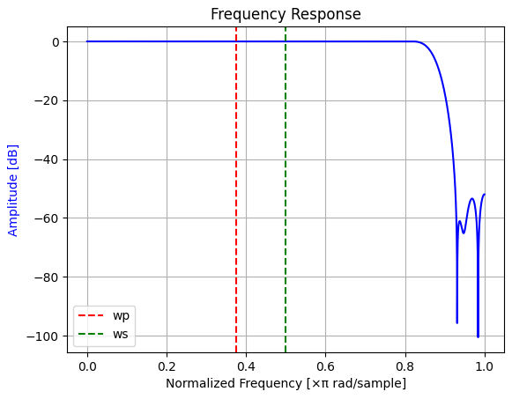 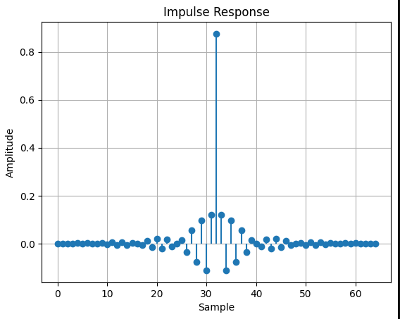 TASK#6: Blackman Window: Write a Python program to design an FIR filter using the Blackman window. Perform the following steps: Define the input specifications: wp = 0.375 * np.pi, ws = 0.5 * np.pi. Calculate the order of the filter using the formula N = int(np.ceil(8 * np.pi / (ws - wp)) + 1). Calculate the cutoff frequency: Wc = (wp + (ws - wp) / 2) / (0.5 *np.pi). Calculate the filter coefficients using the Blackman window: h_blackman = firwin(N, Wc,window='blackman'). CODE: 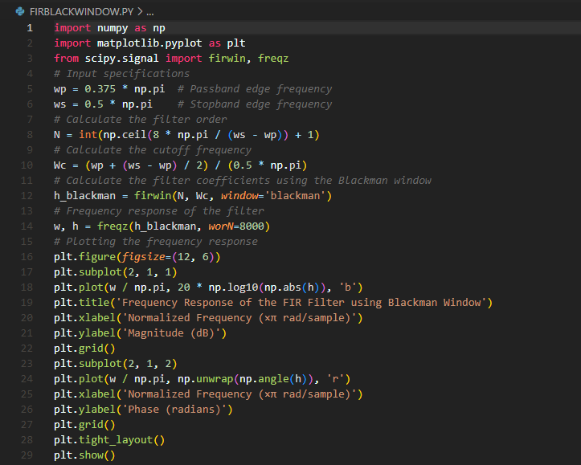 Graph: 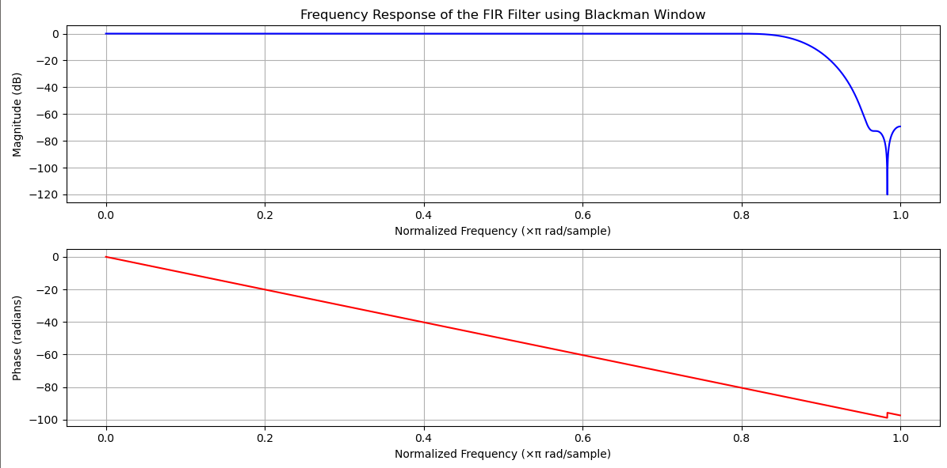 TASK#7: Kaiser Window: Write a Python program to design an FIR filter using the Kaiser window. Perform the following steps: Define the input specifications: wp = 0.375 * np.pi, ws = 0.5 * np.pi. Calculate the order of the filter using the formula N = int(np.ceil(8 * np.pi / (ws - wp)) + 1). Calculate the cutoff frequency: Wc = (wp + (ws - wp) / 2) / (0.5 * np.pi). Set the beta parameter for the Kaiser window: beta = 8. Calculate the filter coefficients using the Kaiser window: h_kaiser = firwin(N, Wc, window=('kaiser',beta)). Plot the frequency response and impulse response for the Kaiser window. Display the plots. CODE:

